Part B: UDP ECHO Server and Client (C)

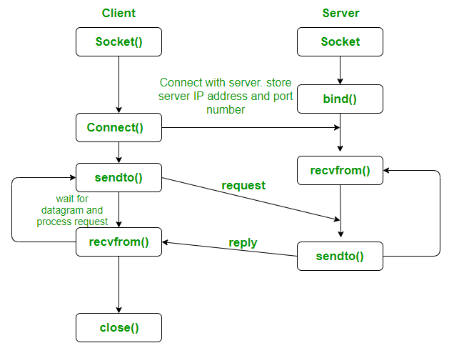

udp_echo_server.c
#include <stdio.h>
#include <string.h>
#include <stdlib.h>
#include <unistd.h>
#include <netinet/in.h>

#define PORT 10055
#define BUF_SIZE 1024

int main() {
int sockfd;
struct sockaddr_in server, client;
char buffer[BUF_SIZE];
socklen_t len = sizeof(client);

sockfd = socket(AF_INET, SOCK_DGRAM, 0);

server.sin_family = AF_INET;
server.sin_port = htons(PORT);
server.sin_addr.s_addr = INADDR_ANY;

bind(sockfd, (struct sockaddr *)&server, sizeof(server));

printf("UDP Echo Server listening on port %d...\n", PORT);

while (1) {
memset(buffer, 0, BUF_SIZE);
recvfrom(sockfd, buffer, BUF_SIZE, 0, (struct sockaddr *)&client, &len);
printf("Received: %s", buffer);
sendto(sockfd, buffer, strlen(buffer), 0, (struct sockaddr *)&client, len);
}

close(sockfd);
return 0;
}

udp_echo_client.c
#include <stdio.h>
#include <string.h>
#include <stdlib.h>
#include <unistd.h>
#include <netinet/in.h>

#define PORT 10055
#define BUF_SIZE 1024

int main() {
int sockfd;
struct sockaddr_in server;
char buffer[BUF_SIZE];
socklen_t len = sizeof(server);

sockfd = socket(AF_INET, SOCK_DGRAM, 0);

server.sin_family = AF_INET;
server.sin_port = htons(PORT);
server.sin_addr.s_addr = INADDR_ANY;

while (1) {
printf("Enter message: ");
fgets(buffer, BUF_SIZE, stdin);
sendto(sockfd, buffer, strlen(buffer), 0, (struct sockaddr *)&server, len);

memset(buffer, 0, BUF_SIZE);
recvfrom(sockfd, buffer, BUF_SIZE, 0, (struct sockaddr *)&server, &len);
printf("Echo from server: %s", buffer);
}

close(sockfd);
return 0;
}

